Game Design Document

Fill up the Following document

1. Write the title of your project.

THE HAUNTED HOUSE.

1. What is the goal of the game?

TO GET INSIDE THE HOUSE AND COLLECT THE GOLD COINS

AND SAVE HIS FRIEND.

1. Write a brief story of your game?

A BOY WHO IS IN SEARCH OF HIS FRIEND GETS INTO A HOUSE

WHICH IS UNFORTUNATELY HAUNTED. HE IS AFRAID THE

GHOST WILL EAT HIM. SO, HE TRIES TO ESCAPE FROM THE GHOST AND COLLECT THE GOLD COINS AND ALSO SAVE HIS FRIEND

1. Which are the playing characters of this game?

* Playing characters are the ones which respond to the user based on the input from the user
* Cars, monkeys, dinos, wizards etc, are the playing characters in the game.

|  |  |  |
| --- | --- | --- |
| Number | Character Name | What can this character do? |
| 1 | the boy | chase the ghost and save his friend |
| 2 | the death eater | eat creatures |
| 3 | lizard | scare people |
| 4 | spiders | scare people |
| 5 | bat | scare people |
| 6 |  |  |
| 7 |  |  |
| 8 |  |  |

1. Which are the Non-Playing Characters of this game?

* Non-Playing characters are the ones which don't have an action or a behavior when the user interacts with the game.
* Hurdles, stones, bananas, coins, etc. are non-playing characters in the game.

|  |  |  |
| --- | --- | --- |
| Number | Character Name | What can this character do? |
| 1 | STONES | STOP THE PLAYER FOR A WHILE |
| 2 | LAVA | SCARE THE PLAYER AND STOP HIM FOR A WHILE |
| 3 | COINS | THE PLAYER HAS TO COLLECCT THEM |
| 4 | INVISIBLE BOAST | IF THE PLAYER COLLECTS THEM, HE BECOMES INVISBLE |
| 5 | POWER BOAST | IF THE PLAYER COLLECTS THEM HIS SPEED BECOMES DOUBLE |
| 6 | COOL FIRE BOAST | IF THE PLAYER COLLECTS THEM, HE CAN WALK ON FIRE |
| 7 | JUMP UP HIGH BOAST | IF THE PLAYER COLLECTS THEM, HE CAN JUMP VERY HIGH |
| 8 |  |  |

Draw your imagination of this game. What does this game look like?

* Draw the game either on your computer or on paper,
* 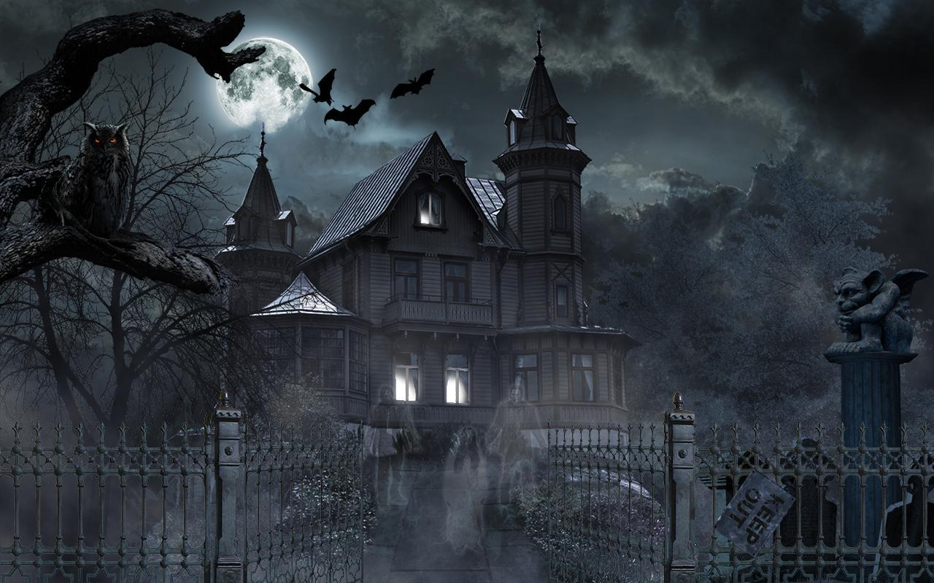Add images of scenes of the game to show each of the playing and non-playing characters at least once.

{display image}

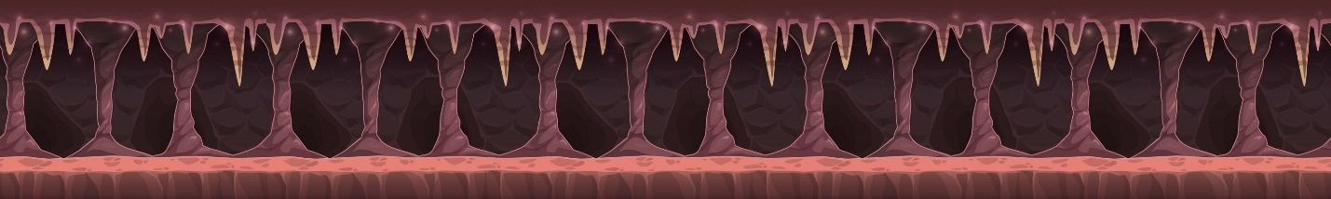

{bg 1}

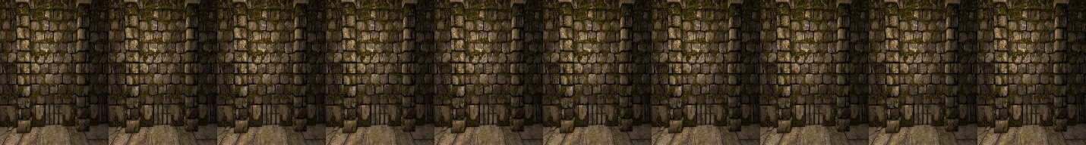

{bg 2}

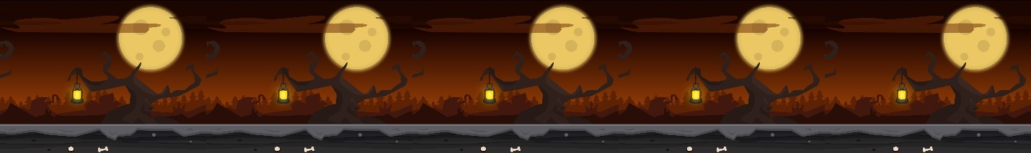

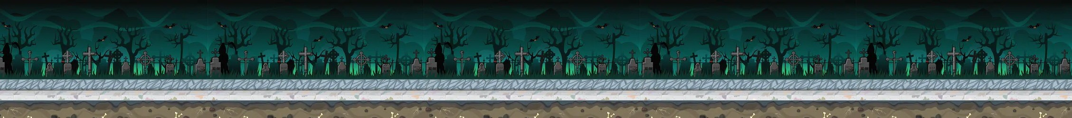

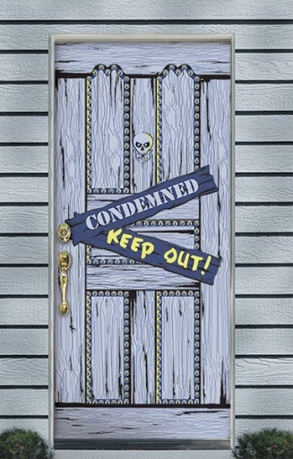{bg 4}

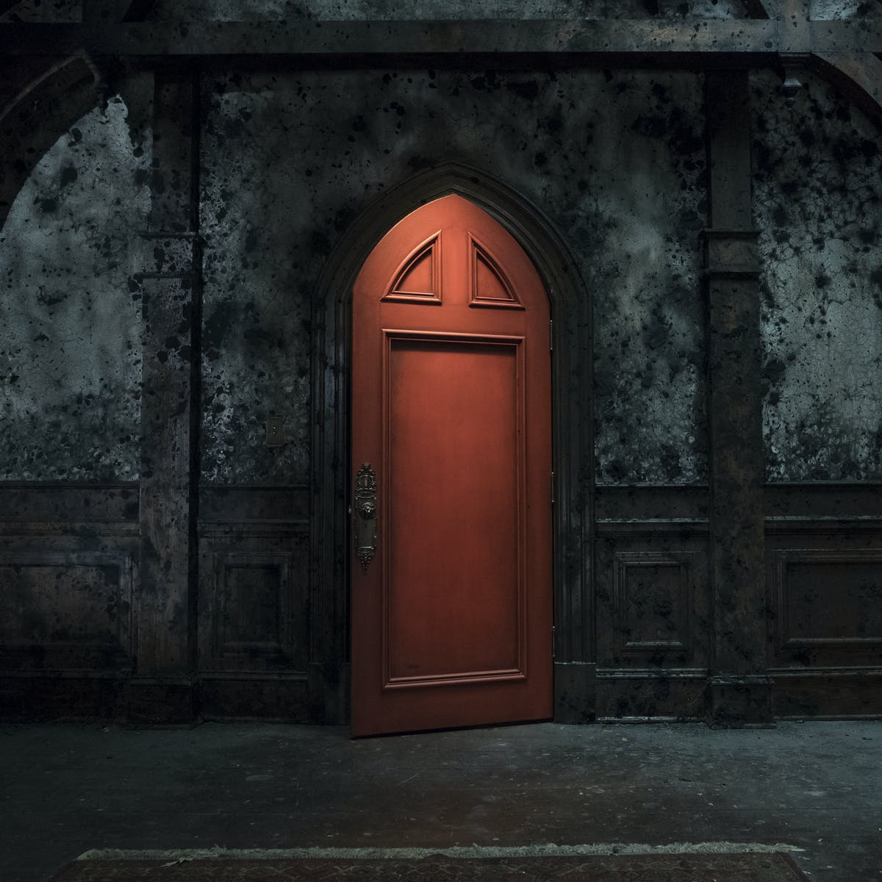

{door choosing images}

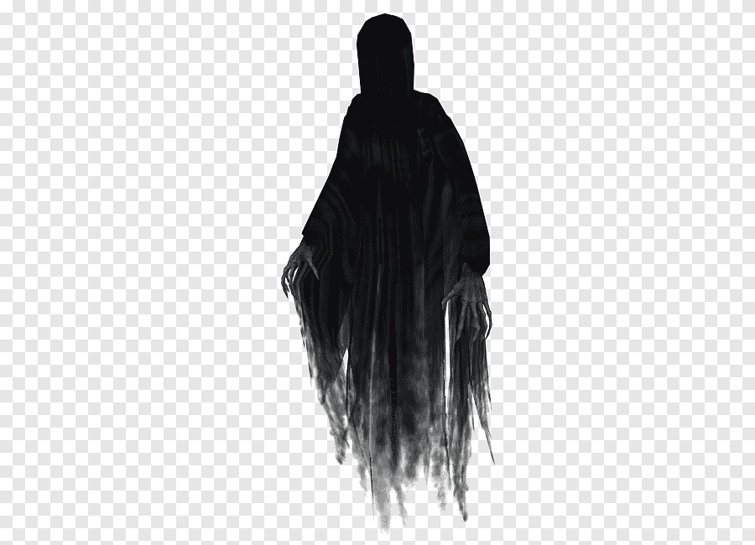{ghost images}

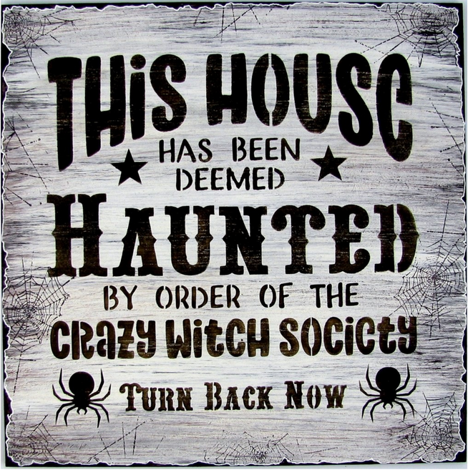{warning image}

How do you plan to make your game engaging?

MAKE THE PLAYER GET EXCITING REWARDS AFTER REACHING

SOME DISTANCE. ADD SCORES SO THAT IT WILL BE FUN FOR THE

PLAYER TO KNOW WHAT HIS SCORE IS..